**Problem-3**

**Student Name: Milan Sharma UID: 23MAI10003**

**Branch: ME – CSE - AIML Section/Group: MAI– 1 (A)**

**Semester: 1st Date of Performance:**

**Subject Name: Python Programming Subject Code: 23 CSH 623**

1. **Aim of the Experiment :**

Write a program to obtain length (*L*) and breadth (*B*) of a rectangle and check whether its area is greater or perimeter is greater or both are equal.

1. **Objective of the Experiment :**

Objective of the Experiment is that we have to calculate the calculated area and perimeter print "Area" if area is greater otherwise print "Peri" and if they are equal print "Eq".

1. **Algorithm/ Steps for Experiment :**

Step 1:Takes two integer inputs from userone is the lengthand another is breadth.

Step 2:Calculate the area of rectangle by formula area=l*b.

Step 3: Calculate the perimeter of rectangle by formula peri=2(l*b).

Step 4: Check condition for area<peri if true print Value of perimeter and also print peri.

Step 4: If the condition is false check for area>periand then the condition is true print value of the area of the rectangle along with the output area.

Step 5: If the condition is false print the Eq in else also area of rectangle.

1. **Code for Experiment :**

l=int(input())

b=int(input())

area = l*b

peri = 2*(l+b)

if area<peri:

print("Peri")

print(peri)

elif area>peri:

print("Area")

print(area)

else:

print("Eq")

print(area)

1. **Result/Output :**

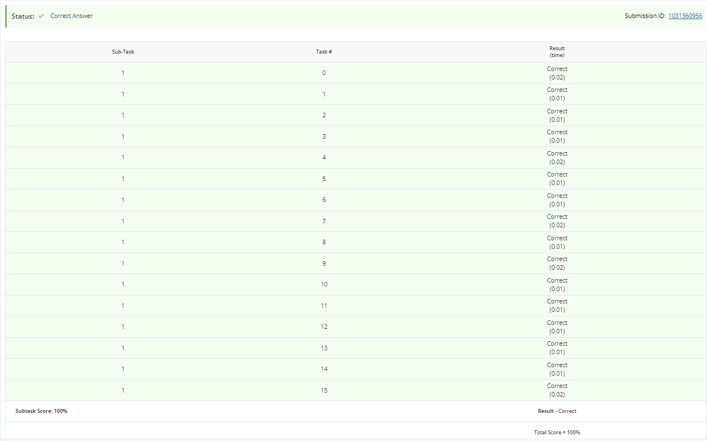

**Learning outcomes (What I have learnt):**

1. Learnt about the python programming.
2. Learnt how to take input from the user in integer.
3. Learnt how to calculate area and perimeter of rectangle in python.
4. Learnt about if else and nested if conditional statement in python.